


ENGLISH ASSIGNMENT 1.1

Topic: A cultural event-
HANAMI FESTIVAL

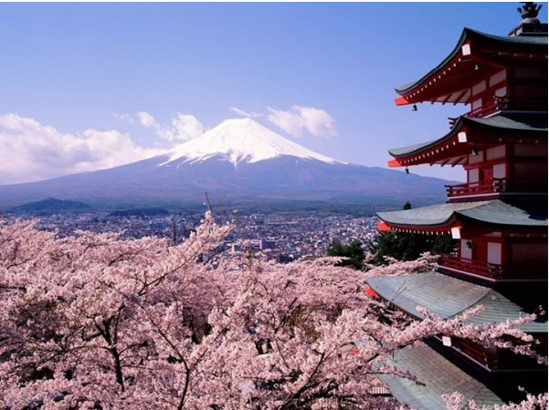

Teacher : | NguyenNH
Student : | Nguyen Quoc Tuan
SID : | PH08378
Class : | ENT1123.1

OUTLINE

- INTRODUCTION
Introduction of Hanami Festival
- BODY
1. All of Hanami Festival
2. Traditional Food - Cultural Activities
3. My Experience and Feelings of Hanami
- CONCLUSION

Hanami and The Last words

- Introduction
Introduction of Hanami Festival
Japan is known around the word for it’s cherry blossom festival. Known as “hanami” in Japanese, hanami festival are an important custom and are held all over Japan during the sprin. That said, do not expect to see the flowers wherever you go, the trees bloom at differrent time throughout Japan. If you’re planning a trip to the country in the spring, here’s what you need to known about the hanami tradition.

